Price Drivers

- Weak sowing progress of Rabi crop.
- Expected increase in demand from the poultry sector.
- Lowered forecasts for US inventories, tightening global food supplies after adverse weather slashed harvests.

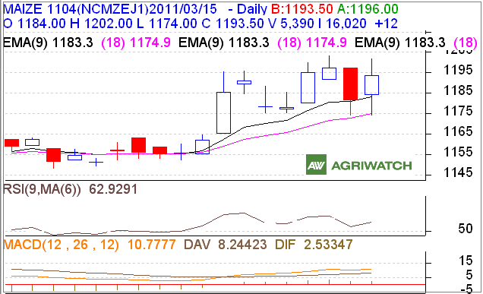

Technical Analysis:
- Candle stick chart pattern indicates sideways movement of maize price in futures market.
- Prices closed above 9 day and 18 day EMA, supporting short term upward movement of prices ahead.
- RSI is moving down in the neutral region supporting bearish movement.
- MACD is moving up indicating bullish sentiment in the market for short term.
- Market participants are advised to buy at around 1190.

Trade Recommendation – Maize NCDEX (April Contract)
Call | Entry | T1 | T2 | SL
Buy | 1190 | 1194 | 1198 |  | 1185
Support & Resistance
S2 | S1 | PCP | R1 |  | R2
1156 | 1166 | 1193.5 | 1203 |  | 1214

International Market (CBOT)

US corn futures finish slightly higher, snapping a six-session slide as users of the grain enter the market looking for a bargain. Buyers remain nervous about supplies, which are projected to fall to a 15-year low by the end of the crop's marketing year on Aug. 31. Trader suspect prices may have established a near-term low after reports of devastation in Japan did not push the market to a fresh low early Monday. The market dropped nearly 11% last week. CBOT May corn rises 1 3/4c to $6.66.

Market Analysis

- Mostly firm tone of sentiment witnessed in major key cash maize markets on Tuesday.
- The Delhi, prices remained steady on absence of fresh buying at current supply. Maize prices are likely to trade steady to firm in next trading session.
- In Nizamabad, maize prices gained Rs. 40/Qtl on pickup in demand from starch industries despite spurt in market arrivals. The maize prices may remain on firm side tomorrow. Rabi maize arrivals in Andhra Pradesh have started hitting spot markets in small quantities. Moisture content of 13-14% is reported in the fresh arrivals.
- In Davangere, prices gained by Rs. 10/Qtl on fresh buying from industrial users and exporters at lower supply. Maize prices are likely to remain on the firm side in next trading session as strong demand is still seen in the market. Tight supply of maize is reported in the market.
- Reportedly, fresh maize arrivals in Bihar have started in very small quantities which are supporting a negligible market activity. Arrivals in higher quantities are likely to start after Holi.
- In Ahmadabad, prices were up for both the poultry feed and starch grade maize by Rs. 20 and 30/Qtl respectively, on higher demand amid restricted supply. According to trader, daily average requirement is now around 20,000 bags while, supply much lower than the quantity demanded. The prices may remain on the higher side tomorrow.
- Maize export from India is likely to slow down if domestic prices continue on rising as higher prices may divert maize importing countries towards Argentina, due to lower parity and which also has better quality cargo.
We feel that prices are likely to trade steady to firm for medium term on good demand from the industrial users and exporters. However, Rabi season arrivals may exert some pressure on prices.

NCDEX Warehouse Stock (in Tonnes)
Location | Dematted Stocks |  | Change
Location | 14/03/11 | 12/03/11 | Change
Nizamabad | 1439 | 1439 | Unch
Davangere | 1555 | 1555 | Unch
Maize Total | 2944 | 2944 | Unch

Spot Prices at Key Markets
Centre | Prices  15-03-11 | Chng From Prior day | Arrivals  15-03-11 | Chng From Prior day
Delhi | 1225 | Unch | 400 | Unch
Nizamabad | 1200 | +40 | 1300 | +1000
Davangere | 1190 | +10 | 700 | -300
Naughachia | - | - | - | -
*Prices in Rs/Qtl, Arrivals in Bags (1 bag =1 qtl), All are Bilty prices except in Delhi which is for Hybrid maize
DISCLAIMER The information and opinions contained in the document have been compiled from sources believed to be reliable. The company does not warrant its accuracy, completeness and correctness. Use of data and information contained in this report is at your own risk. This document is not, and should not be construed as, an offer to sell or solicitation to buy any commodities. This document may not be reproduced, distributed or published, in whole or in part, by any recipient hereof for any purpose without prior permission from the Company. IASL and its affiliates and/or their officers, directors and employees may have positions in any commodities mentioned in this document (or in any related investment) and may from time to time add to or dispose of any such commodities (or investment). Please see the detailed disclaimer at http://www.agriwatch.com/Disclaimer.asp

