Commodity: Refined Soybean Oil Exchange: NCDEX
Contract: June Expiry: June 20th, 2011
REFINED SOYBEAN OIL (RSBO)
Technical Commentary:  - Candlestick chart pattern reveal buying support in the market  - Prices closed above 9-day and 18-day EMA supporting the bulls in near and medium-term.  - MACD is rising in positive territory.  - RSI is rising in neutral region while stochastic is easing in neutral zone.  Soy oil prices are likely to improve in Saturday’s session. |  |  | 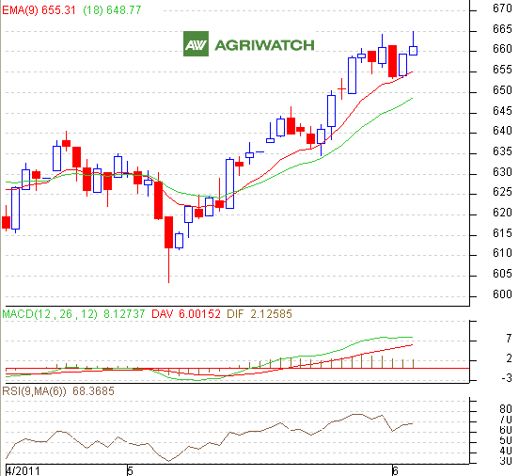
Strategy: Soybean oil price is likely to trade range bound
Intraday Supports & Resistances |  |  | S2 | S1 | PCP | R1 | R2
Refined Soy Oil | NCDEX | June | 652 | 656 | 661.7 | 670 | 674
Intraday Trade Call |  |  | Call | Entry | T1 | T2 | SL
Refined Soy Oil | NCDEX | June | BUY | >659 | 664 | 666 | 654
Commodity: Crude Palm Oil Exchange: MCX
Contract: June Expiry: June 30th, 2011
CRUDE PALM OIL (CPO)
Technical Commentary:  - Candlestick chart pattern reveals selling pressure in the market.  - Prices closed above 9-day and 18-day EMA supporting the bulls in near and medium term.  - RSI and stochastic are easing in neutral region.  CPO prices are likely to ease in Saturday’s session . |  |  | 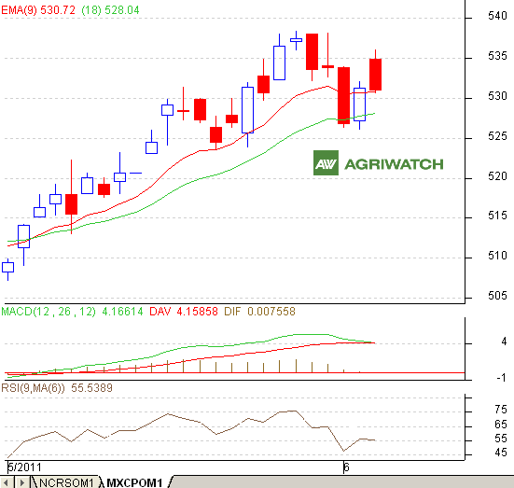
Strategy: Crude Palm oil is likely to trade range bound
Intraday Supports & Resistances |  |  | S2 | S1 | PCP | R1 | R2
Crude Palm Oil | MCX | June | 527 | 529 | 530.9 | 537 | 540
Intraday Trade Call |  |  | Call | Entry | T1 | T2 | SL
Crude Palm Oil | MCX | June | SELL | <533 | 530 | 528 | 537
*Do not carry forward the position until next day.

