Commodity: Maize Exchange: NCDEX
Contract: July Expiry: July 20th, 2011
MAIZE
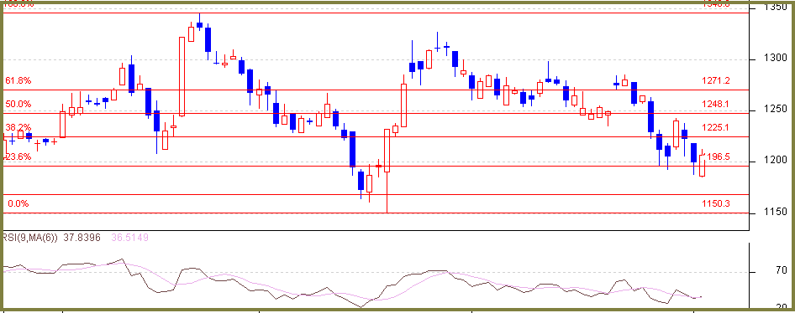

Technical Commentary:
- Maize, short term price trend continue to be weak, however price reaches near a significant support juncture.
- 1170, on the lower side is a capable support whereas 1220 on the higher side is a important resistance and until price closes above the same, bears will keep the upper hand.
- Positioning of RSI in Daily Chart remains favorable to bears.

Strategy: Sell at rise, while keeping in mind, nearness of the price to significant support level
Intraday Supports & Resistances |  |  | S2 | S1 | PCP | R1 | R2
Maize | NCDEX | July | 1170 | 1185 | 1206.50 | 1220 | 1235
Intraday Trade Call |  |  | Call | Entry | T1 | T2 | SL
Maize | NCDEX | July | SELL | <1215 | 1200 | 1185 | 1222
Do not carry forward the position until the next day.

