**Executive Summary**

Domestic oilseeds and meal market featured gains as expected with renewed seasonal domestic demand in edible oils and meals. In addition, parity in crushing the soybean remained encouraging for crushers and solvent extractors for bean crushing.

India’s soy meal prices are getting competitive compared with the South American meal prices. The spread between Argentine soy meal price and Indian meal prices has narrowed down during the week under review. Soy meal demand is seen improving with rise in poultry production on seasonal demand. Poultry feed industry remained keen in buying the meal. Besides, continued demand of soy meal from SE Asia, West Asia and Africa remained supportive for the Indian soy meal exports.

RM seed prices remain in tandem with soybean seed prices on account of improved miller’s demand and comparative lower supplies. Stockists are seen buying the seed at lower levels to fetch off-season premiums during Nov-Jan, when the usage increases.

However, favorable weather condition for domestic soybeans along with satisfactory planting progress, improved weather conditions in US and higher Malaysian palm oil stocks are some of the bearish factors which may limit excessive gains in oil complex. CPO production in Malaysia witness marked increase in June according to MPOB, raising stocks to an 18-month high of 2.05 Mn T.

**International**

**US:** In it’s last report the soybean crop rating was discouraging primarily due to dry weather condition in some soybean growing regions posing threat to yield. However, weather forecasts point to some cooling-down of temperatures in parts of the US Midwest. Any negative deviation from its trend line yield might push up the soybean price at benchmark CBOT. Overall, strong old crop export sales, with higher crude oil futures and a weaker U.S. dollar stands supportive for US soybeans with spill over strength to the domestic soybean prices.

**Soybean & Soy meal:** The global soybean output in 2010/11 must total 264.12 million tons. The estimate was made by SAFRAS and Mercado, partly based on data from the United States Department of Agriculture (USDA), which puts outturn at 263.69 million. Last year, global production was projected at 260.84 million tons.This translate

Oil World estimates world exports of soya meal at a new high of 43.6 Mn T in Oct/June 2010/11, representing an increase by 4.1 Mn T from a year earlier. Reportedly the European Union alone is likely to increase soya meal imports by about 2.2 Mn T. This is likely to support the soymeal prices at higher levels. Soybean crushing and net exports of the USA, Argentina and Brazil (the G-3 countries) declined to a combined 17.5 Mn T in June.

Argentina's 2010-11 soy production is seen totaling 48.80 million tonnes, down from a previous estimate of 49.6 million tonnes as a result of severe dryness. Argentine farmers finished the 2010/11 harvest a couple of week and the government forecast means production slipped by 7.4 percent from last year's record high.

**Rapeseed:** The international rapeseed complex has been supported by the recent uptrend of soybean and palm oil prices. Ukraine’s rapeseed output prospects have deteriorated in contrast to the favourable outlook for grains and sunflowerseed. Reportedly Canadian canola stocks will be unexpectedly low at around 750 Thd T when the 2010/11 season ends in July.

**Oil Meal Prices at Key Spot Markets:**

**Soy DOC Rates at Different Centers**

|  |  |  |  |
| --- | --- | --- | --- |
| **Centers** | **Ex-factory rates (Rs/ton)** | | |
| **23-07-11** | **16-07-2011** | **Parity To** |
| Indore (MP) | 16700 | 16400-16500 | Gujarat, MP |
| Kota | 16700-16800 | 16600 | Rajasthan, Del, Punjab, Haryana |
| Akola | 16700 | 16700 | Andhra, Chattisgarh, Orissa,Jharkhand, WB |
| Hingoli | 17700-17800 | 17500-17700 | Andhra, Chattisgarh, Orissa,Jharkhand, WB |
| Nanded/Latur | 17700-17800 | 17500-17700 | Andhra, AP, Kar ,TN |
| Dhulia/Jalna | 17900 | 17600 | Mumbai, Maharashtra |
| Nagpur (42/46) | 17200-17300 | 17100 | Chattisgarh, Orissa, Bihar, Bangladesh, AP, Kar, TN |
| Sangli | 18600-18700 | 18600 | Local and South |
| Solapur | 18200-18300 | 18300 | Local and South |

**Soy DOC at Port**

|  |  |  |
| --- | --- | --- |
| Centers | Port Price | |
| **16-07-11** | **09-07-2011** |
| Kandla (FOR) (INR/MT) | 18100-18200 | 17600 |
| Kandla (FAS) (USD/MT) | 408-410 | 395 |

**International Soy DOC**

|  |  |  |  |
| --- | --- | --- | --- |
| **Argentina FOB $/MT** | **23-07-11** | **16-07-2011** | **+/-** |
| Soybean Pellets | 384 | 378 | **+6** |
| Soybean Cake Meal | 384 | 378 | **+6** |
| Soybean Meal | 392 | 386 | **+6** |
| Soy Expellers | 392 | 386 | **+6** |

**Sunflower Meal Rates**

|  |  |  |  |
| --- | --- | --- | --- |
| **Centers** | **Ex-factory rates (Rs/ton)** | | |
| **23-07-11** | **16-07-2011** | **Change** |
| Adoni | 14200 | 14200 | **Unch** |
| Khamgaon | 13200 | 13100 | **+100** |
| Latur | 13800 | 13600 | **+200** |
| Parli | 13800 | 13600 | **+200** |

**Groundnut Meal**

|  |  |  |  |
| --- | --- | --- | --- |
| **Groundnut Meal** | **23-07-11** | **16-07-2011** | **Chg** |
| Basis 45% O&A, Saurashtra | 15250 | 14700 | **+550** |
| Basis 40% O&A, Saurashtra | 14250 | 13900 | **+350** |
| GN Cake, Gondal | 16000 | 15000 | **+1000** |

**Mustard DOC/Meal**

|  |  |  |  |
| --- | --- | --- | --- |
| **Mustard DOC/Meal** | **2-07-11** | **16-07-2011** | **Chg** |
| Jaipur (Plant Delivery) | 7000 | 6500 | **+500** |
| Kandla (FOR) | 7950 | 7500 | **+450** |
| Sri Ganganagar | 930 | 890 | **+40** |

**Planting Progress – Oilseeds, India**

Theoverall area for*Kharif*oilseeds is still trailing due to deficit in rains in Gujarat and some part of Maharashtra. The event has consequently negatively affected the groundnut planting in Gujarat, Karnataka, Andhra Pradesh and Maharashtra.The lag in GN planting varies from 40% - 56% in different growing states.

However, the monsoon rainfall has improved in central Indiawhich helped in boosting soybean sowing in the state and subsequently improving the crop prospect.

Currently, the overall area covered under various oilseeds is reported at 129.75lakh hectares compared to about 129.49lakh hectares in the corresponding periodlast year (as on 22 July 2010).

Soybean planting is nearing completion in all the major growing states with total area covered so far is 91.21 lha which is 98 per cent of the area covered last year. In Madhya Pradesh the covered area is reported at 54.77 lha. In Maharashtra the planting is done in 93 per cent at 23.47 lha. In Rajasthan the area is covered in 8.16 lha which is above last year’s estimated area of 7 lha.Soybean planting in Andhra and Karnataka is almost close to the last year’s coverage. In Chhattisgarh planting is slightly delayed due to heavy rains since last couple of weeks.

The planting progress in some of the *kharif* oilseed growing states is as follows:

|  |  |  |  |
| --- | --- | --- | --- |
| **Sowing Progress - Oilseeds Area in lha.** | | | |
| **Andhra Pradesh** (As on 20.07.11) | ***Current*** | ***Corresponding Period Last Year*** | ***% Change*** |
| Groundnut | 4.32 | 9.92 | -56% |
| Sesamum | 0.3 | 0.72 | -58% |
| Castor | 1.1 | 1.48 | -26% |
| Sunflower | 0.04 | 0.14 | -71% |
| Soybean | 1.3 | 1.16 | 12% |
| Other oilseeds | 0.002 | 0 |  |
| **Total** | **7.062** | **13.42** | **-47%** |
| **Maharashtra** (As on 22.07.11) |  |  |  |
| Groundnut | 1.34 | 2.21 | -39% |
| Sesamum | 0.22 | 0.44 | -51% |
| Sunflower | 0.07 | 0.38 | -81% |
| Soybean | 20.92 | 23.22 | -10% |
| Nigerseed | 0.10 | 0.18 | -45% |
| Other Oilseeds | 0.07 | 0.04 | 63% |
| **Total** | **22.72** | **26.47** | **-14%** |
| **Rajasthan** (As on 19.07.11) |  |  |  |
| Groundnut | 3.670 | 2.650 | 38% |
| Sesamum | 2.960 | 1.560 | 90% |
| Soybean | 8.160 | 5.290 | 54% |
| Catorseed | 1.030 | 0.600 | 72% |
| **Total** | **15.82** | **10.1** | **57%** |

On contrary, in Rajasthan the oilseeds planting is ahead from its schedule and witness marked improvement for soybean, groundnut, sesamum and castorseed y-o-y.

Planting is slow in Andhra Pradesh due to deficit rains over Rayalseema S(-42% deviation of normal) and Telangana (-15% deviation of normal rainfall) regions of the state.

Coastal Andhra Pradesh is reported to have received normal rains (with -8% deviations from its normal). Overall status of the monsoon in AP is deficit with -18% deviation of the normal rainfall. Slow planting in Andhra Pradesh and Karnataka has already negatively affected the soybean, groundnut and sunflower planting. Soybean and groundnut planting to finish by Aug, there is still time for sunflower which is usually planted late. Any sharp improvement during the last time might brighten the production prospect of Kharif oilseed moving forward. Besides, there are reports that groundnut area to improve in Tamil Nadu.

**Indicative Soybean Plant Density and Yield:**

The response of farmers interviewed in major soybean growing states of Madhya Pradesh, Maharashtra and Rajasthan reveal the soybean seed rate vary from state to state and variety to variety. Theoretically, seed rate depends on seed size. Generally, 75-80 kg of seeds/ha is recommended.

However, practically the average seed rate in Madhya Pradesh this year is recorded at 86kg seeds/ha, in Maharashtra at 65 kg seeds/ha and 72 kg seeds/ha in Rajasthan respectively. There is no marked variation of seed rate could be seen y-o-y in all the three states.

Considering germination to 80% we expect plant density of 432338 in Madhya Pradesh followed by 362070 plants/hectare in Rajasthan and 324000 plant/hectare in Maharashtra. Considering the normal plant density over these regions we expect soybean yield to stayabove 1010 kg/ha if weather remains favourable.

**YoY Comparative Soybean Crush Margin**

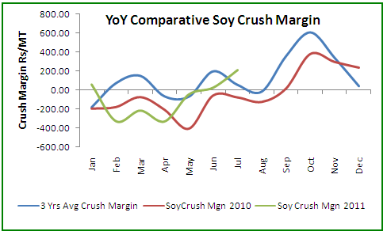

Increase in soy meal shipments and improving crush parity remained encouraging factor for the solvent extractors to crush the beans. The soybean crush parity entered in the positive zone in mid-June and since then the parity remained intact in positive zone.

The weekly crush margin is ruling around Rs164/MT compared with Rs226/MT previous week and Rs-96/MT in the corresponding period last month.

The above chart reflects that the ruling crush margin stay above its3 year average and well above its previous year, primarily supported by better meal exports resulting good revenue in soy meal this season.

The scenario is supportive for soybean crush in near-term. The expected crush margin next week is projected at Rs150-200/MT.

**Soymeal Dynamics**

Domestic soy meal prices improved as expected on rise in fresh domestic demand from poultry industry coupled with continued overseas demand attributed to proximity, logistic and freight advantage.

The soy meal price of Indian origin stood close to our competitor Argentina during the period of review. The spread between meal price FAS Kandla Vs FOB Argentina is seen gradually narrowing.

**Soy meal spread – FAS Kandla Vs FOB Argentina**

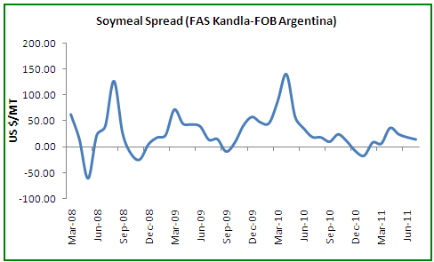

*FAS, Kandla less FOB Argentina

Current price spread between FAS Kandla and FOB Argentina is recorded around US $15/MT compared to US$23/MT last week. The spread is narrowing warranting comfortable situation for Indian meal exports in days ahead. The spread is close to its 3 years average spread of USD 10/MT when active trade and exports takes place. We further expect the spread to narrow down towards US $10/MT.

The narrowing of the spread has further made our meal price competitive in unison with rise in parity in crushing, consequently encouraging the crushers to crush the beans. We recommend the meal exporters to aggressively look for the potential markets to increase the soy meal shipments.

SE Asia, West Asia and Africa remain our potential market for meal exports. It is viable to explore the exports opportunity in African countries to supply our non-GMO meal to meet their growing demand.

Currently, about 20-23 crushing plants with 500 MT of crush capacity per day are in operation for 20 days a month in *Malwa* region of Madhya Pradesh. Looking at the current scenario, it is concluded that an average of about 16 crushing units will be operation till September. This translates about 4 lakh tones of soybean to be crushed during the period, till September, which will result in the production of 3.2 lakh tones of meal and about 0.72 lakh tones of soy oil out of the crushed amount. Considering the facts we project soy meal export to stay firm during Aug – Sep which is likely to keep soybean seed and meal prices on encouraging note moving forward.

**Technical Analysis:**

**NCDEX Soybean Futures (Aug) Soybean Spot, Indore**

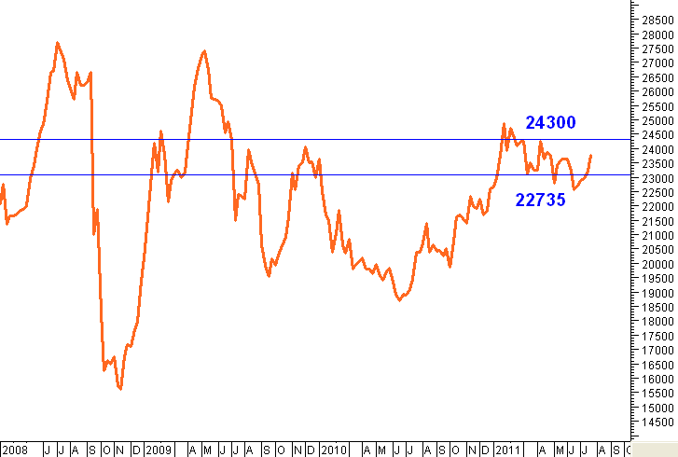

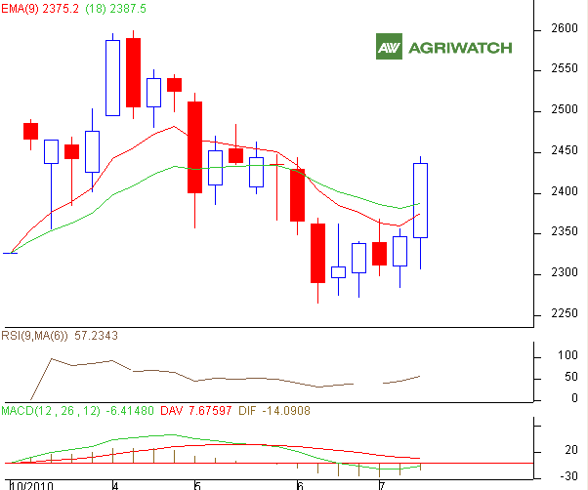

**\*In Rs/MT**

|  |  |  |  |  |
| --- | --- | --- | --- | --- |
| Supports & Resistances NCDEX Soybean- Aug | | | | |
| S2 | **S1** | **PCP** | **R1** | **R2** |
| 2275 | **2299** | **2437** | **2486** | **2523** |

* Candlestick chart pattern strong buying support in the market. Prices closed above 9-day and 18-day EMA supporting bullish momentum. Oscillators and price indicators reflect prices to gain during the week. The soybean prices are likely to remain range-bound with firm-bias and are expected to move towards 2470–2480 levels.

**Trade Recommendation (Soybean) – 1 Week:** Buy on dips towards 2300 – 2310 levels.T1 – 2480; T2 - 2520; SL - 2210

**Spot:** We recommend ***Buy***on dips towards 2320 - 2300 levels.

**Rapeseed - Mustard Seed and RM Oil**

The domestic RM seed prices extended gains on supportive buying from millers with renewed seasonal demand in RM oil. The mustard oil usage improves with the increase in snacks consumption during monsoon.

Considering RM seed prices at Alwar,seed prices quotedat 2875/Qtl (inclusive of all taxes), meal prices at 6600/T, the cost of expeller oil is calculated at 767/10 kg (exclusive of profit margin).

However, the local cost of expeller oil was seen at 634/10 kg which is selling below the crushers cost. This indicates either severe revenue loss to the crushers or there is a fair possibility of blending other low cost edible oil to mustard to bring its cost down.

After adding profit margin, total cost of crude rape oil to refiner stay close to 805/10 kg which is at higher rates when compared to the local available rape oil. Indicating higher RM oil prices when compared to other edible oil we negate any sharp price movement. However, any significant rise in other edible oils might give an edge for pure RM oil which utmost required by the refiners at present text.

The RM seed crush margin to stay negative around -1670/MT during the week, considering the processing cost at Rs1500/MT, RM meal recovery at 58% and RM oil at 40%, Jaipur basis.

**RM Seed Prices Vs Arrivals, Jaipur/Rajasthan**

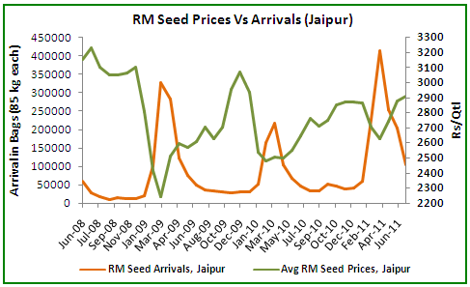

It is evident that the big stockists in RM seed are keen in holding the seed which is evident with the fall in the seed supplies. This is in anticipation of rise in the seed prices towards festive season in association with seasonal demand which picks-up in late July.

It is viable and suggested to buy RM seed at major fall in the price to log in the profit in near-to-medium-term.

**RM Seed Supply, Rajasthan**

|  |  |  |
| --- | --- | --- |
| **RM Seed Arrivals in Rajasthan in Bags (85 kg each)Wkly Avg.** | | |
| **CurrentWeekly Arrivals** | **1 Week Ago** | **Corresponding Period Last Year** |
| 80,000 | 90,000 | 41,500 |

**Technical Analysis:**

**NCDEX RM Seed Futures (Aug) RM Seed Spot, Jaipur**

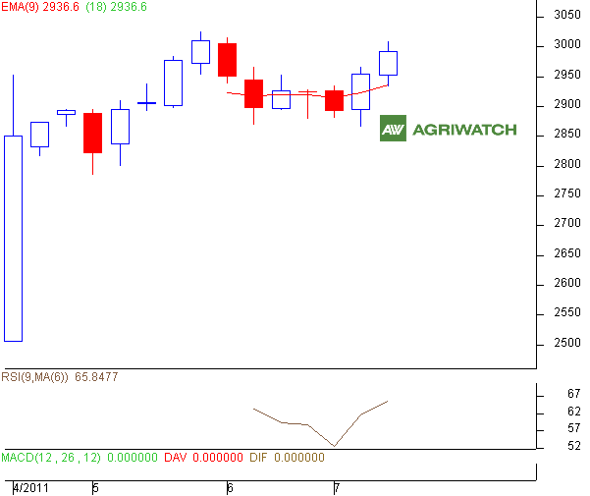

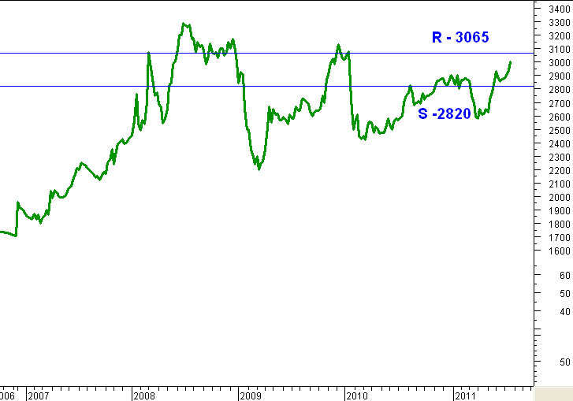

|  |  |  |  |  |
| --- | --- | --- | --- | --- |
| Supports & Resistances NCDEX RM Seed - Aug | | | | |
| S2 | **S1** | **PCP** | **R1** | **R2** |
| 2867 | **2910** | **2998** | **3030** | **3050** |

* RM seed charts pattern indicates continued buying support in the market. The weekly price closed above 9-day and 18-day EMA supporting bulls in near and medium-term. Price indicators and oscillators reflect prices might move up. The RM seed prices are expected to rise and move ***towards 3010 –3020 levels.***

**Trade Recommendation (RM SEED) – 1 Week:** Buy on dips towards 2930 – 2900 levels. T1 - 3020; T2 -3030; SL - 2885.

**Spot:** In spot, we suggest ***Buy*** on dips towards 2830levels.

|  |
| --- |
| Disclaimer |
| The information and opinions contained in the document have been compiled from sources believed to be reliable. The company does not warrant its accuracy, completeness and correctness. Use of data and information contained in this report is at your own risk. This document is not, and should not be construed as, an offer to sell or solicitation to buy any commodities. This document may not be reproduced, distributed or published, in whole or in part, by any recipient hereof for any purpose without prior permission from the Company. IASL and its affiliates and/or their officers, directors and employees may have positions in any commodities mentioned in this document (or in any related investment) and may from time to time add to or dispose of any such commodities (or investment). Please see the detailed disclaimer at <http://www.agriwatch.com/Disclaimer.asp>  © 2005 Indian Agribusiness Systems Pvt Ltd. |