**Executive Summary**

India’s oilseeds and oil meal prices extended gains as expected followed by renewed seasonal and festive demand in edible oils and oilmeals. Continued overseas soy meal shipments during the lean crushing period along with the parity on crushing remained encouraging for solvent extractors.

The demand is likely to further improve in the days ahead with festivities setting in along with falling weather temperature, when edible oil usage increases and soy meal demand picks-up on increased purchases from poultry feed industry.

Seasonal rise in poultry production with relative meal demand from poultry feed industry coupled with overseas demand in Indian soy meal lent support to the soy meal prices and expected to further support the prices. Consistent demand of Indian soy meal from SE Asia, West Asia and Africa is attributed to logistic, freight and non-GMO meal advantage.

RM seed prices featured a gradual upward move in association with soybean backed by miller’s demand with increase in RM oil usage. Waning seed supplies and reluctant stockists who have slowed down off-loading their stock in anticipation higher seed prices remained bullish for the seed.

In the international front concern over US soybean crop output followed by lower yield potential and increasing crude prices indicate bulls to the soybean and RM seed complex.

However, higher reported soybean area this season, In India, and FOA’s alert on possible resurgence of bird flu in India which may affect the domestic soy meal off-take are seen as the bearish factors for soybean complex in domestic front.

**International**

**World:** World soybean production in 2011/12 is projected at 258.1 Mn T, a fall of 3% from last year, the fall is attributed to a smaller US outturn followed by lower yield potential. Higher demand from Asia (China) will raise further growth in world trade in 2011/12, forecast to rise to a record 96.4 Mn T (92.5 Mn), as reported by IGC.

Global soy meal trade is estimated at 60.3 Mn T (58.3 Mn), the year-on-year expansion resulting from bigger purchases by the EU and Far East Asia estimated by IGC.

As per Oil World, the global Aug. 31, 2011, soybean stocks is expected to exceed estimates and keep soybean supplies in the upcoming 2011/12 season sufficient despite a lower-than-forecast crop.

"World ending stocks of the 2010/11 season will be higher than expected at a record 75.8 million tonnes (on Aug. 31), approximately 10.0 million tonnes above a year ago," Oil World said. "This will considerably moderate the prospective production shortfall and result in an increase in total soybean supplies by 7.1 million tonnes or 1.8 percent to 337.2 million tonnes in 2011/12."

Of the total Aug. 31 soybean stocks, aobut 6.63 million tonnes are forecast by Oil World to be in the United States, up from 4.11 million tonnes in Aug. 2010.

About 26.03 million tonnes of the stocks are expected to be in Brazil, up from 18.66 million tonnes last year and 25.58 million tonnes in Argentina, up from 25.05 million tonnes last August.

Oil World has trimmed its estimate of global soybean production in the new 2011/12 season to 261.42 million tonnes, down 4.9 million tonnes from its estimate in July and down by 3.9 million tonnes against the 2010/11 harvest.

"The biggest decline will occur in the U.S., for which we are currently using a crop estimate of 84.37 million tonnes which is 1.2 million tonnes above the USDA (U.S. Department of Agriculture estimate of Aug. 11," Oil World said. This would be down from 90.61 million tonnes in the previous U.S. crop.

It is expected despite high stocks, the factors will still permit global 2011/12 soybean crushings to rise to 233.30 million tonnes from 222.78 in 2010/11, Oil World forecast.

**US:**

Private forecasters in US are consistently projecting lower yield potential due to dry weather – high temperature during the period of review. In the official US crop progress setting pods are reported at 93 per cent vs 5 year average of 94 per cent, dropping leaves is reported at 2 per cent against 5 year average of 6 per cent. The crop is rated good to excellent condition at 57 per cent against 64 per cent last year.

The current temperature in US soybean growing belt is ranging between 60 – 77 degrees.

**Pro Farmer US Soybean Crop Estimate – Crop Tour**

|  |  |  |
| --- | --- | --- |
| **States** | **Yield (bushel per acre)** | **Remark** |
| **Ohio** | 45 | The crop needs time and water to finish strong. |
| **Indiana** | 44 | Disease and bug pressure were limited. Rains required. |
| **Illinois** | 49 | The northern half of the crop has adequate plenty of moisture to finish with a good yield. |
| **Iowa** | 53 | Record yield expected if the crop gets a rain. |
| **Minnesota** | 39 | The crop is under moisture stress since pod-set. |
| **Nebraska** | 52.5 | The crop is disease-free. |
| **South Dakota** | 39 | Crop needs one more rain to recover the health. |
| **Avg. US Yield** | **41.8** | - |

**Source: Pro Farmer**

The US 2011 soybean output is estimated at 3.08 billion bushels with projected yield of 41.8 bushel per acre by Pro Farmer after a recent crop tour. The above table contains the estimated yield figures, in some of the states, concluded after the findings by Pro Farmer.

However, Pro Farmer experts believe USDA will eventually lower the harvested area for soybean which stands at 73.8 million acres. Pro Farmer has used USDA’s harvested acreages to estimate the total soybean output.

The yield estimate (41.8 bu/acre) is slightly up compared to USDA’s 41.4 bu/acres projected in August 1, this is attributed to one of the most disease free soybean crop found by the tour team.

Variation of +/- 2% will result in 40.96 bu. to 42.64 bu. per acre with subsequent change in production at 3.02 billion to 3.14 billion bushels.

**China:** As per sources China is expected to add 12.3 million tonnes of soy crushing capacity this year to boost the country's total soy processing capacity to around 100 million tones. It is also estimated that China will process 55 million tonnes of soybeans in 2011, which translates a fall of an operational ratio of 9.1 per cent compared to 2010 and a fall of 6.9 per cent in compared with 2009 operation ratio.

**Oilseed Prices at Key Spot Markets:**

| **Commodity** | **Centre** | **Prices (Rs/Qtl)** | | **Change** |
| --- | --- | --- | --- | --- |
| **Soybean** |  | **27-08-11** | **20-08-11** |  |
| Indore –Plant | 2400-2440 | 2380-2425 | **+15** |
| Indore –Mandi | 2300-2350 | 2260-2315 | **+35** |
| Nagpur-Plant | 2450-2520 | 2480-2530 | **-10** |
| Nagpur – Mandi | 2350-2425 | 2425-2500 | **-75** |
| Kota-Plant | 2380-2420 | 2340-2370 | **+50** |
| Kota – Mandi | 2300-2350 | 2240-2280 | **+70** |
|  |  |  | | |  |
| **Rapeseed/Mustard** | Jaipur – C | 3045-3050 | 2995-3000 | **+50** |
| Alwar – C | 2915 | - | **-** |
| SriGanganagar (NC) | 2550 | 2500 | **+50** |
| Kota | - | 2750 | **-** |
| Neewai | 3010 | 3000 | **+10** |
| Delhi– C | 3010 | 2980 | **+30** |
| Hapur (UP) | 3005 | 3050 | **-45** |
|  |  |  |  |  |
| **Groundnut Seed** | Rajkot | 810 | 790 | **+20** |
| Junagarh | - | - | **-** |
|  |  |  |  |  |
| **Sunflower Seed** | Latur | 2900-3200 | 2900-3200 | **Unch** |
|  | Gulbarga | - | - | **-** |
|  | Solapur | 3150-3350 | 3150-3300 | **+50** |

Soybean Prices are in INR/Qtl. Mandi prices – Loose, Mustard Seed Prices are in INR/Qtl.C – Condition (42%), *Groundnut seed inRs/20 kg, Sunflower Seed in Rs/Qtl

**Oilseed Arrivals in Key Centers:**

|  |  |  |  |  |
| --- | --- | --- | --- | --- |
| **Commodity** | **Centre** | **Arrivals in Bags/Qtl** | | **Change** |
| **Soybean** |  | **27-08-11** | **20-08-11** |  |
| Madhya Pradesh | 25000 | 35000 | **-10000** |
| Maharashtra | 10000 | 7000 | **+3000** |
| Rajasthan | 5000 | 4000 | **+1000** |
|  | | | | |  |  |  |
| **Rapeseed/Mustard** | Rajasthan | 44000 | 37000 | **+7000** |
|  | | | | |  |  |  |

**Oil Meal Prices at Key Spot Markets:**

**Soy DOC Rates at Different Centers**

|  |  |  |  |
| --- | --- | --- | --- |
| **Centers** | **Ex-factory rates (Rs/ton)** | | |
| **27-08-11** | **20-08-11** | **Parity To** |
| Indore (MP) | 17500-17700 | 17200-17300 | Gujarat, MP |
| Kota | 17100 | 17300 | Rajasthan, Del, Punjab, Haryana |
| Akola | 17700-17800 | 17500 | Andhra, Chattisgarh, Orissa,Jharkhand, WB |
| Hingoli | 18800-18900 | 18200 | Andhra, Chattisgarh, Orissa,Jharkhand, WB |
| Nanded/Latur | 18800-18900 | 18400 | Andhra, AP, Kar ,TN |
| Dhulia/Jalna | 18700 | 18400 | Mumbai, Maharashtra |
| Nagpur (42/46) | 18800 | 18100 | Chattisgarh, Orissa, Bihar, Bangladesh, AP, Kar, TN |
| Sangli | 19700 | 19100 | Local and South |
| Solapur | 19400 | 18700 | Local and South |

**Soy DOC at Port**

|  |  |  |
| --- | --- | --- |
| Centers | Port Price | |
| **27-08-11** | **20-0811** |
| Kandla (FOR) (INR/MT) | 18500-18800 | 18300 |
| Kandla (FAS) (USD/MT) | 402-407 | 401 |

**International Soy DOC**

|  |  |  |  |
| --- | --- | --- | --- |
| **Argentina FOB $/MT** | **27-08-11** | **20-08-11** | **+/-** |
| Soybean Pellets | 393 | 375 | **+18** |
| Soybean Cake Meal | 393 | 375 | **+18** |
| Soybean Meal | 401 | 383 | **+18** |
| Soy Expellers | 401 | 383 | **+18** |

**Sunflower Meal Rates**

|  |  |  |  |
| --- | --- | --- | --- |
| **Centers** | **Ex-factory rates (Rs/ton)** | | |
| **27-08-11** | **20-08-11** | **Change** |
| Adoni | 14400 | 14400 | **Unch** |
| Khamgaon | 13400 | 13500 | **-100** |
| Latur | 13900 | 13800 | **+100** |
| Parli | 13900 | 14000 | **-100** |

**Groundnut Meal**

|  |  |  |  |
| --- | --- | --- | --- |
| **Groundnut Meal** | **27-08-11** | **20-08-11** | **Chg** |
| Basis 45% O&A, Saurashtra | 16100 | 15500 | **+600** |
| Basis 40% O&A, Saurashtra | 15100 | 14500 | **+600** |
| GN Cake, Gondal | 17100-17200 | 16500 | **+700** |

**Mustard DOC/Meal**

|  |  |  |  |
| --- | --- | --- | --- |
| **Mustard DOC/Meal** | **27-08-11** | **20-08-11** | **Chg** |
| Jaipur (Plant Delivery) | 7000 | 6650 | **+50** |
| Kandla (FOR) | 8200 | 7750 | **+450** |
| Sri Ganganagar | 960 | 908 | **+52** |

**Planting Progress – Oilseeds, India**

All India *Kharif* oilseeds coverage area were up 3% ending August 2011, the overall area covered under various oilseeds is reported at 174.31 lakh hectares compared to about 169.79 lakh hectares in the corresponding period last year.

The *Kharif* oilseeds planting are almost done and the planting progress is relatively low now. The planting was initially hit in Gujarat, Karnataka and Andhra Pradesh affecting Groundnut plantings, but it slightly recovered with later rains. Overall the GN planting is still lagging by 14%.

Soybean planting is heading among all the *Kharif* oilseeds by 11% and reported at 103.1 lha compared to 93.27 during the same period last year.

The planting progress in some of the *kharif* oilseed growing states is as follows:

|  |  |  |  |
| --- | --- | --- | --- |
| **Sowing Progress - Oilseeds Area in lha.** | | | |
| **Andhra Pradesh** | ***Current*** | ***Corresponding Period Last Year*** | ***% Change*** |
| Groundnut | 10.01 | 13.46 | -26% |
| Sesamum | 0.34 | 0.81 | -58% |
| Castor | 2.24 | 1.86 | 20% |
| Sunflower | 0.13 | 0.44 | -70% |
| Soybean | 1.55 | 1.39 | 12% |
| Other oilseeds | 0.008 | 0.11 | -93% |
| **Total** | **14.28** | **18.07** | **-21%** |
| **Maharashtra** |  |  |  |
| Groundnut | 2.20 | 2.57 | -14% |
| Sesamum | 0.39 | 0.49 | -20% |
| Sunflower | 0.28 | 0.48 | -42% |
| Soybean | 30.46 | 25.92 | 18% |
| Nigerseed | 0.36 | 0.38 | -5% |
| Other Oilseeds | 0.77 | 0.93 | -17% |
| **Total** | **34.46** | **30.77** | **12%** |
| **Rajasthan** |  |  |  |
| Groundnut | 4.240 | 3.470 | 22% |
| Sesamum | 4.100 | 5.470 | -25% |
| Soybean | 8.820 | 7.650 | 15% |
| Catorseed | 1.600 | 1.490 | 7% |
| **Total** | **18.76** | **18.08** | **4%** |

The oilseeds planting progress in Rajasthan and Maharashtra is higher than last year’s coverage followed by timely and adequate rains over the states.

Oilseeds planting in Andhra Pradesh have already affected due to poor rains over the state, initially or at the time when planting was ideal. Groundnut (-26%), Sesamum (-58%) and Sunflower (-70%) plantings badly suffered in the state. However, Soybean and Castor seed plantings were satisfactory in AP.

**First Crop Production Forecast**

|  |  |  |  |  |
| --- | --- | --- | --- | --- |
| **State** | **Area (lha)** | **Yield (kg/ha)** | **Production (L MT)** | **% Change** |
| **Madhya Pradesh** | 59 | 1191 | 69.63 | 14.17 |
| **Maharashtra** | 30 | 1148 | 34.97 | 26.97 |
| **Rajasthan** | 9 | 1352 | 11.92 | 56.16 |
| **Total India** | **103.09** | **1192** | **123.00** | **21.45** |

In the extension of our telephonic survey in key soybean growing states, the standing crop is reported to be in Good to Excellent condition and free from disease and pest. In Maharashtra the crop is under pod-filling stage, it is in flowering/pod-filling stage in Madhya Pradesh and vegetative/ flowering in Rajasthan.

Considering our last study on seed and germination rate followed by plant density, we project India’s soybean yield at 1192 kg/ha.

**Soybean Production Outlook- Projections:** Considering the soybean sown area of about 103.09 lha and projected yield at 1192kg/ha. The total India’s soybean output is estimated at around 12.3 Mn T (123 lt).

**Soy meal- FAS Kandla Vs FOB Argentina (Spread)**

Renewed seasonal domestic demand coupled with good overseas shipments remained key supportive factors for the domestic soy meal prices during the period of review. The poultry feed industry is the major buyer of the meal to meet the poultry feed demand, with seasonal rise in poultry production.

The meal export during April 2011 to July 2011 is 7,37,522 MT as compared to 3,74,135 MT in the same period of previous year showing an increase of 97.13%.

During current oil year, (October – September), the meal exports during October 2010 to July 2011 is 37,35,369 MT as against 18,78,501 MT last year, an increase by 98.85%. India’s exports of soy meal during July, 2011 was 1,39,551 tonnes as compared to 1,60,622 tonnes in July, 2010 showing a fall of 13.12% over the last year.

Countries like Japan, Vietnam, Indonesia, China and Thailand remained the major destinations for Indian soy meal exports.

Growing demand of non-GMO soy meal from Far-East, and SE Asian countries and logistics and freight advantage remained a supportive factor for Indian soy meal exports. Emerging markets like West Asia and Africa could be seen as long-term buyers.

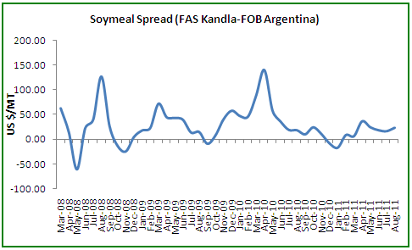

*FAS, Kandla less FOB Argentina

The price spread between Indian and Argentine soy meal has slight narrowed during the period of review.

The weekly spread between FAS Kandla and FOB Argentina is hovering around US $6/MT compared to US$24/MT previous week.

We expect a gradual the spread to stay around US $10/MT in days ahead (September), the level at which the active trade and shipments takes place.

Continued surge in soybean crush parity and good overseas soy meal inquiries continue to remain encouraging to the solvent extractors.

It is recommended that the meal exporters aggressively look towards the potential markets like SE Asia, West Asia and Africa to increase the soy meal shipments.

As per sources, about 20-23 soybean crushing units with 500 MT of crush capacity per day are in operation for 20 days a month in the *Malwa* region of Madhya Pradesh. Out of these about 16 crushing units are believed will be operating till September. This translates to about 1.8 lakh tonnes of soybean will be crushed by September, which will in turn result in the production of 1.44 lakh tonnes of meal and about 0.32 lakh tonnes of soy oil. Considering the facts we feel that the Indian soy meal shipments to stay at higher levels during Sep which will lend underlying support to meal prices in particular and subsequently soybean.

We expect domestic soy meal prices to stay slightly firm in near-term on renewed buying support from feed industry.

**Soy meal Dynamics and Crush Margin**

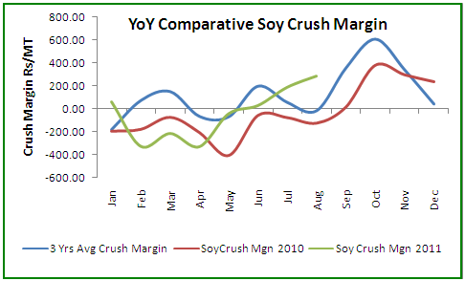

Soybean crush parity significantly improved m-o-m as reflected in the chart above. This is primarily attributed to the good overseas soy meal exports. Currently, the parity is well above last year’s monthly average and even above 3 year monthly average.

The weekly crush margin is ruling around Rs152/MT compared toRs109/MT last previous week. The rising crush margin trend is supportive for soybean crush in near-term.

**Technical Analysis:**

**NCDEX Soybean Futures (Sep.) Soybean Spot, Indore**

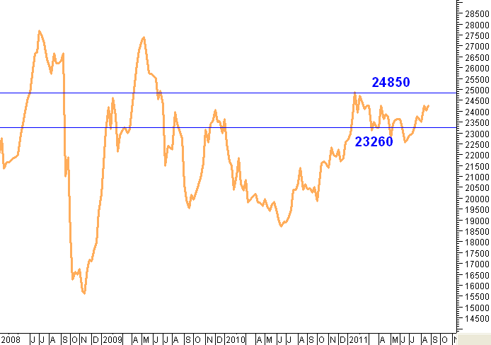

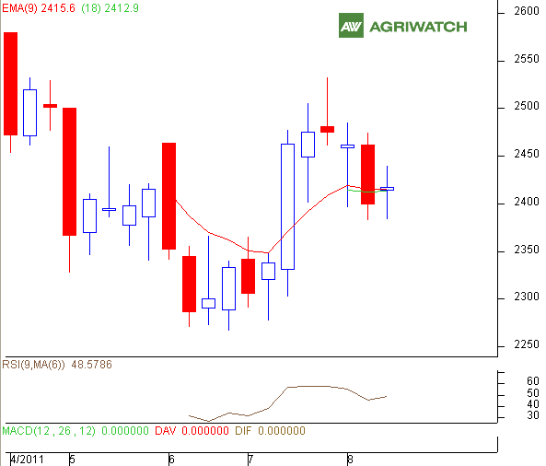

|  |  |  |  |  |
| --- | --- | --- | --- | --- |
| Supports & Resistances NCDEX Sep Soybean | | | | |
| S2 | **S1** | **PCP** | **R1** | **R2** |
| 2346 | **2367** | **2417.5** | **2450** | **2475** |

**\*In Rs/MT**

* The weekly candlestick chart pattern featured indecision in the market, but prices in downtrend
* Prices closed above 9-day and 18-day EMA supporting bullish momentum in near and medium-term.
* Oscillators and price indicators indicate prices to fall during the week. The soybean prices are likely to remain range-bound with weak -bias and are expected to move towards 2380 – 2385 levels.
* **Trade Recommendation (NCDEX Soybean - Sep) – 1 week:** Sell on rise towards 2430 – 2440 levels.T1 – 2360; T2 - 2360; SL - 2473
* **Spot:** We recommend ***Sell*** on rise towards 2470 – 2480 levels.

**Rapeseed - Mustard Seed**

The domestic RM seed prices extended gains during week followed by supportive buying from millers on renewed seasonal demand in RM oil. However, the RM seed prices tend to get mild pressure with the commencement of the early soybean crop arrivals during September which again gain in October.

Stockists have slowed down offloading the seed in anticipating of higher prices during winter. The RM oil demand surges in between Nov – Jan.

**RM Seed Prices Vs Arrivals, Benchmark - Jaipur**

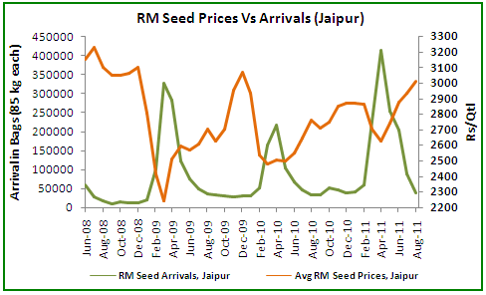

Arrivals during the period of review stood at 178000 bags compared to 177000 bags a week ago.

**RM Seed Supply, Rajasthan**

|  |  |  |
| --- | --- | --- |
| **RM Seed Arrivals in Rajasthan in Bags (85 kg each).** | | |
| **Weekly Arrivals** | **1 Week Ago** | **Corresponding Period Last Year** |
| 1,78,000 | 1,77,000 | 1,52,000 |

Besides, RM oil and rapeseed-mustard extract demand drives the RM seed complex. Better exports and domestic usage of extract and rise in RM oil usage remain supportive to the RM seed prices. Overall, the underlying RM seed fundamentals remain strong in days ahead on seasonal demand.

**Technical Analysis:**

**NCDEX RM Seed Futures (Sep.) RM Seed Spot, Jaipur**

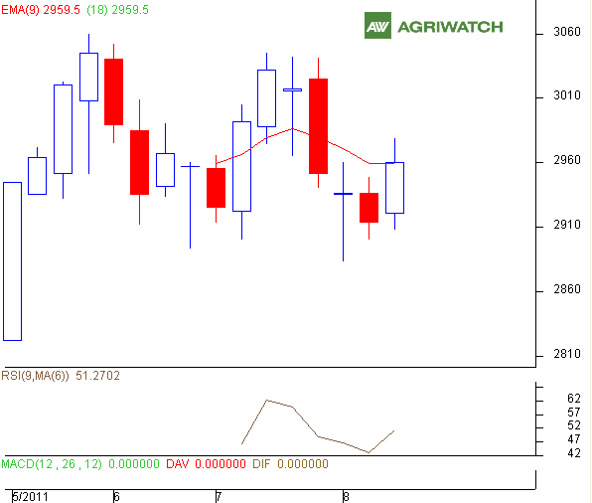

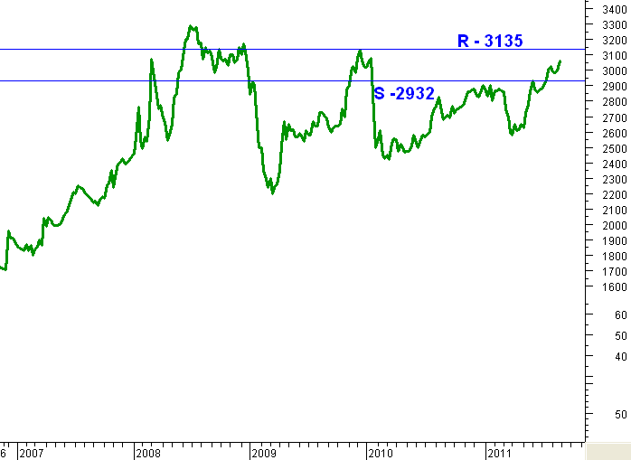

|  |  |  |  |  |
| --- | --- | --- | --- | --- |
| Supports & Resistances NCDEX Sep RM Seed | | | | |
| S2 | **S1** | **PCP** | **R1** | **R2** |
| 2883 | **2900** | **2961** | **2988** | **3005** |

* The weekly candlestick chart pattern reveals buying support during the week.
* Prices closed above 9-day and 18-day EMA supporting bullish momentum.
* However, price indicators and oscillators reflect prices to fall during the week. The RM seed prices are expected to fall and move towards 2900 levels.
* **Trade Recommendation (NCDEX RM SEED - Sep) – 1 Week:** Sell on rise towards 2980 – 2985 levels.T1 – 2950; T2 - 2940; SL - 2998.

**RM Seed Spot:** In spot the RM seed prices are expected to fall during the week towards 2940 – 2930 level. We recommend ***Sell*** on rise.

|  |
| --- |
| Disclaimer |
| The information and opinions contained in the document have been compiled from sources believed to be reliable. The company does not warrant its accuracy, completeness and correctness. Use of data and information contained in this report is at your own risk. This document is not, and should not be construed as, an offer to sell or solicitation to buy any commodities. This document may not be reproduced, distributed or published, in whole or in part, by any recipient hereof for any purpose without prior permission from the Company. IASL and its affiliates and/or their officers, directors and employees may have positions in any commodities mentioned in this document (or in any related investment) and may from time to time add to or dispose of any such commodities (or investment). Please see the detailed disclaimer at <http://www.agriwatch.com/Disclaimer.asp>  © 2005 Indian Agribusiness Systems Pvt Ltd. |