Commodity: Refined Soybean Oil Exchange: NCDEX
Contract: October Expiry: October 20th, 2011
REFINED SOYBEAN OIL (RSBO)
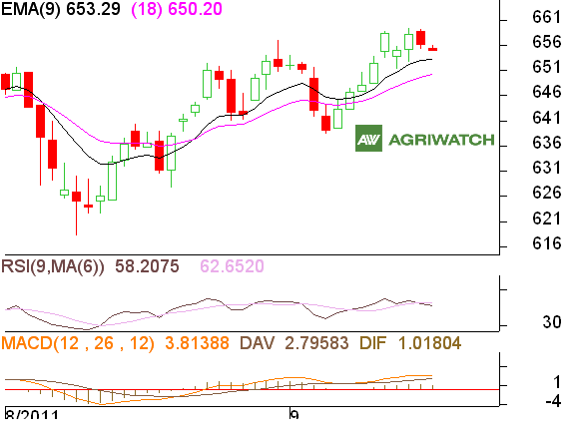

Technical Commentary:

- Ref. Soy oil candlestick depicts bearish movement in market.
- Positioning of RSI is down in neutral zone depicts range bound with weak bias movement in prices.
- Prices closed above 9 and 18 day’s EMA suggesting firm bias movement in prices.

Market participants are suggested to go for sell from the resistance levels.

View: Soybean oil price is likely to trade with weak bias.
Intraday Supports & Resistances |  |  | S2 | S1 | PCP | R1 | R2
Refined Soy Oil | NCDEX | October | 650 | 653 | 654.85 | 659 | 662
Intraday Trade Call |  |  | Call | Entry | T1 | T2 | SL
Refined Soy Oil | NCDEX | October | SELL | 659 | 653 | 651 | 662

Commodity: Crude Palm Oil Exchange: MCX
Contract: October Expiry: October 30th, 2011

CRUDE PALM OIL (CPO)
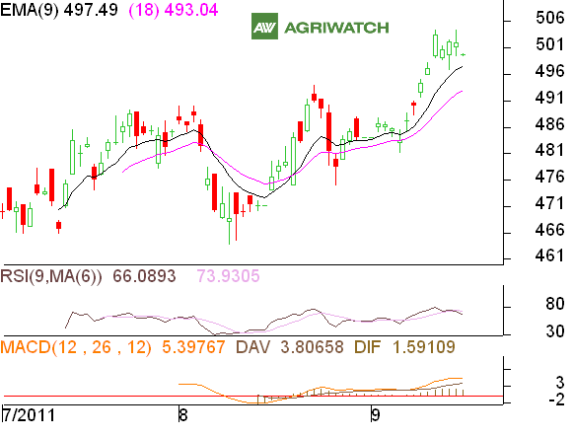

Technical Commentary:

- CPO candlestick depicts fall in the prices.
- RSI is easing in neutral region while stochastic is falling in overbought zone.
- Prices closed above 9 and 18 day’s EMA suggesting firmness in price movement.
- Prices likely remain range bound with weak bias in today’s trading session.

Market participants are suggested to go for sell on rise.

Strategy: Crude Palm oil likely to trade weak bias.
Intraday Supports & Resistances |  |  | S2 | S1 | PCP | R1 | R2
Crude Palm Oil | MCX | October | 494 | 496.8 | 499.4 | 502 | 504
Intraday Trade Call |  |  | Call | Entry | T1 | T2 | SL
Crude Palm Oil | MCX | October | SELL | 503 | 498 | 496 | 506
*Do not carry forward the position until next day.

Disclaimer
The information and opinions contained in the document have been compiled from sources believed to be reliable. The company does not warrant its accuracy, completeness and correctness. Use of data and information contained in this report is at your own risk. This document is not, and should not be construed as, an offer to sell or solicitation to buy any commodities. This document may not be reproduced, distributed or published, in whole or in part, by any recipient hereof for any purpose without prior permission from the Company. IASL and its affiliates and/or their officers, directors and employees may have positions in any commodities mentioned in this document (or in any related investment) and may from time to time add to or dispose of any such commodities (or investment). Please see the detailed disclaimer at http://www.agriwatch.com/Disclaimer.asp
© 2005 Indian Agribusiness Systems Pvt Ltd.

Disclaimer
The information and opinions contained in the document have been compiled from sources believed to be reliable. The company does not warrant its accuracy, completeness and correctness. Use of data and information contained in this report is at your own risk. This document is not, and should not be construed as, an offer to sell or solicitation to buy any commodities. This document may not be reproduced, distributed or published, in whole or in part, by any recipient hereof for any purpose without prior permission from the Company. IASL and its affiliates and/or their officers, directors and employees may have positions in any commodities mentioned in this document (or in any related investment) and may from time to time add to or dispose of any such commodities (or investment). Please see the detailed disclaimer at http://www.agriwatch.com/Disclaimer.asp
© 2005 Indian Agribusiness Systems Pvt Ltd.

