SPOT MARKET HIGHLIGHTS
- Firm sentiment recorded in the major key guar cash markets during this fortnight.

- Overall arrivals in the spot market were lower during this season.
- Lower carry-in stocks in the spot markets.
- By-products(Churi & Korma) demand subdued in the spot market due to surplus supply.

FUNDAMENTALS:
- Strong sentiment witnessed in majority of key cash markets of Guar seed and Guar gum during this fortnight.
- Guar seed and Guar gum prices are increased during this fortnight due to increased demand in domestic market as well as in overseas market.
- Guar prices supported by the restricted arrivals in the spot market due to bad weather condition and as a result guar prices moved upside during this season.Overall guar seed arrivals (all India) during the fortnight recorded at 9, 55,000 bags, which are lower by 4, 20,000 bags as compared to the previous fortnight arrivals.
- As per the trader’s projection, overall arrivals in the spot market will continue to be lower side in coming days, which may move prices to upside in near term.
- Another supporting factor for the increasing guar prices is the projections of lower carry- in stocks which might result in tight supplies during next season.
- As per market participants, renewal in the Guar gum export demand from the US and China is actively responsive once again after the Christmas and New Year vacations which also support the guar gum as well as guar seed prices in the spot market.
- An expectation of increase in the crude oil extraction activities in near term is likely to support the guar gum prices.
- As per trade sources, increasing guar gum exports in the current season influencing increase in higher procurement by the processors in the spot market during this session, which also support the guar seed and guar gum prices to go upside.
- Guar by-product (Churi & Korma) prices declined in the spot market due to excess supply as a result of higher production.

We believe that Guar seed and Guar gum may trade range bound with firm bias during coming fortnight due to the projections of lower arrivals in the spot market and higher export demand.
FUTURES MARKET HIGHLIGHTS
GUARSEED: February contract ended with gain this fortnight and traded to a high of Rs.2576 and to a low of Rs 2530. Volume touched a high at 141,190 and open interest touched at 102,950
GUARGUM: February contract ended with gain this fortnight and traded with a high of Rs 6839 and to a low of Rs 6779. Volume touched at 22,540 and open interest touched at 40,640.

GUAR SEED AND GUAR GUM SPOT PRICES
Commodity | Centres | 06-01-11 | 20-12-10 | Change (%)
Guar seed | Jodhpur (Delivery) | 2525 | 2525 | +0.99
Guar seed | Jodhpur (Loose) | 2275 | 2275 | Unch
Guar seed | Bikaner | 2270 | 2270 | +11.01
Guar seed | Nokha | 2360 | 2360 | +2.12
Guar seed | Hanumangarh | 2390 | 2390 | +2.72
Guar seed | Sri-Ganganagar | 2325 | 2325 | +1.51
Guar seed | Adampur | 2390 | 2390 | +0.42
Guar seed | Sirsa | 2390 | 2390 | +0.42
Guar seed | Bhiwani | 2410 | 2410 | -0.21
Guar seed | Deesa | 2350 | 2350 | +4.26
Guar seed | Dabwali | 2500 | 2500 | -4,80
 | Nagaur | 2240 | 2240 | -0.89
Guar gum | Jodhpur | 6400 | 6400 | +1.56
Guar gum | Bhiwani | 6450 | 6450 | +2.33
Guar gum | Dabwali | 6400 | 6400 | +3.91
(Prices in Quintals)

ARRIVALS
Centres | 06.01.11 20.12.10
All India | 60000 110000
Bikaner | 4000 13000
Nokha | 2000 2000
Hanumangarh | 300 400
Sri-Ganganagar | 800 1200
Adampur | 2000 4000
Deesa | 600 700
Sirsa | 500 2000
Bhiwani | 800 1500
Dabwali | 80 300
Nagaur | 6000 1200

TECHNICAL OUTLOOK: GUM

Guar gum futures witnessed mixed tone sentiment during the last fortnight period. Prices seen a initially a low of 6207 and later moved to a high of 6696. Prices took a strong support at 6207 level and a strong resistance at 6696 level.

Trade Strategy (For February Contract):
In coming fortnight period, February futures prices will take resistance at 6788 level and a support at 6314 level. If prices breeches the level of 6314, then 6011 will be the strong support level. Prices closed above 9 and 18 days EMAs supporting the bullish momentum in the medium term. MACD is moving up in positive territory which indicates bullish sentiment. As bullish sentiment witnessing in market, prices will be in the range between 6324 to 6768 level.

TECHNICAL OUTLOOK: SEED
Guar seed futures witnessed mixed trend during the last fortnight period. Prices initially moved down to 2410 level and due to strong resistance level at 2410 level doesn’t allowed prices to move down. Prices moved higher side to level of 2520 where it is forced by strong resistance level pushed prices down.

Trade Strategy (For February Contract):

In coming fortnight period, February futures contract will trade with price levels between 2578 higher side and 2440 lower side as result of bullish sentiment witnessing in the market. 2438 will be the strong support level and 2576 will be strong resistance level. Prices closed above 9 and 18 days EMAs supporting the bullish momentum in the short term, MACD is moving up in positive territory which indicates bullish sentiment.

Trade Recommendation – Guargum NC
DISCLAIMER The information and opinions contained in the document have been compiled from sources believed to be reliable. The company does not warrant its accuracy, completeness and correctness. Use of data and information contained in this report is at your own risk. This document is not, and should not be construed as, an offer to sell or solicitation to buy any commodities. This document may not be reproduced, distributed or published, in whole or in part, by any recipient hereof for any purpose without prior permission from the Company. IASL and its affiliates and/or their officers, directors and employees may have positions in any commodities mentioned in this document (or in any related investment) and may from time to time add to or dispose of any such commodities (or investment). Please see the detailed disclaimer at http://www.agriwatch.com/Disclaimer.asp

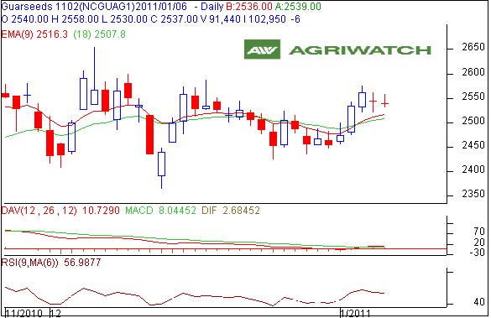
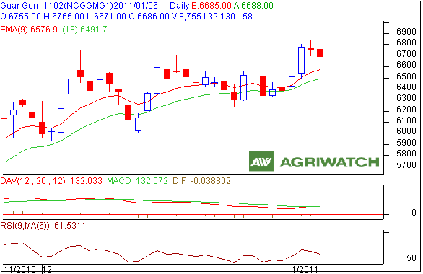
Trade Recommendation:
Guarseed NCDEX (Feb)
Call | Entry | T1 | T2 | SL
BUY | >2445 | 2500 | 2540 | 2437
Support & Resistance
S2 | S1 | PCP | R1 | R2
2396 | 2455 | 2537 | 2565 | 2602

Trade Recommendation:
Guargum NCDEX (Feb)
Call | Entry | T1 | T2 | SL
BUY | >6132 | 6243 | 6516 | 6010
Support & Resistance
S2 | S1 | PCP | R1 | R2
6011 | 6294 | 6686 | 6625 | 6768

