Sharad Krishi Magazine

Sharad Krishi is a multi-lingual magazine dedicated to modern agribusiness, published since January 2005 in Marathi, Hindi and Kannada. It has been received very well by the farmers and other stakeholders, especially in.
Sharad Krishi is a National Magazine. It has received two national awards, namely 'Atmaram Award' from the Ministry of Human Resources, Govt. of India and 'Choudhari Charan Singh Award' from Indian Council of Agricultural Research under the Ministry of Agriculture, Govt. of India.
Sharad Krishi is a unique magazine, which publishes informative articles on globalisation, modern agribusiness, agricultural marketing, agricultural policies and schemes of State and Central Governments, success stories related to agriculture and allied sectors etc. Farmers and other stakeholders use the platform of Sharad Krishi to gain latest knowledge about the global policy and trade environment and get important guidelines for preparedness to face the challenges of globalisation.
Sharad Krishi is managed by a team of professionals located at Pune and Jaipur. This team is backed by number of honorary experts from across the country, who contribute articles, collect news items and success stories, translate and rewrite the articles in language palatable to the readers.
- Thumbnails - (Scanned copy/pdf of cover page with a link to scanned copy/pdf of Index Page for Hindi / Marathi / Kannada Editions)

- 2005 Issues
  - January 2005 (Hindi / Marathi / Kannada)
  - February 2005 (Hindi / Marathi / Kannada)
  - March 2005 (Hindi / Marathi / Kannada)
  - April 2005 (Hindi / Marathi / Kannada)
  - May 2005 (Hindi / Marathi / Kannada)
  - June 2005 (Hindi / Marathi / Kannada)
  - July 2005 (Hindi / Marathi / Kannada)
  - August 2005 (Hindi / Marathi / Kannada)
  - September 2005 (Hindi / Marathi / Kannada)
  - October 2005 (Hindi / Marathi / Kannada)
  - November 2005 (Hindi / Marathi / Kannada)
  - December 2005 (Hindi / Marathi / Kannada)
- 2006 Issues
  - January 2005 (Hindi / Marathi / Kannada)
  - February 2005 (Hindi / Marathi / Kannada)
  - March 2005 (Hindi / Marathi / Kannada)
  - April 2005 (Hindi / Marathi / Kannada)
  - May 2005 (Hindi / Marathi / Kannada)
  - June 2005 (Hindi / Marathi / Kannada)
  - July 2005 (Hindi / Marathi / Kannada)
  - August 2005 (Hindi / Marathi / Kannada)
  - September 2005 (Hindi / Marathi / Kannada)
  - October 2005 (Hindi / Marathi / Kannada)
  - November 2005 (Hindi / Marathi / Kannada)
  - December 2005 (Hindi / Marathi / Kannada)
- 2007 Issues
  - January 2005 (Hindi / Marathi / Kannada)
  - February 2005 (Hindi / Marathi / Kannada)
  - March 2005 (Hindi / Marathi / Kannada)
  - April 2005 (Hindi / Marathi / Kannada)
  - May 2005 (Hindi / Marathi / Kannada)
  - June 2005 (Hindi / Marathi / Kannada)
  - July 2005 (Hindi / Marathi / Kannada)
  - August 2005 (Hindi / Marathi / Kannada)
  - September 2005 (Hindi / Marathi / Kannada)
  - October 2005 (Hindi / Marathi / Kannada)
  - November 2005 (Hindi / Marathi / Kannada)
  - December 2005 (Hindi / Marathi / Kannada)
- 2008 Issues
  - January 2005 (Hindi / Marathi / Kannada)
  - February 2005 (Hindi / Marathi / Kannada)
  - March 2005 (Hindi / Marathi / Kannada)
  - April 2005 (Hindi / Marathi / Kannada)
  - May 2005 (Hindi / Marathi / Kannada)
  - June 2005 (Hindi / Marathi / Kannada)
  - July 2005 (Hindi / Marathi / Kannada)
  - August 2005 (Hindi / Marathi / Kannada)
  - September 2005 (Hindi / Marathi / Kannada)
  - October 2005 (Hindi / Marathi / Kannada)
  - November 2005 (Hindi / Marathi / Kannada)
  - December 2005 (Hindi / Marathi / Kannada)
- 2009 Issues
  - January 2005 (Hindi / Marathi / Kannada)
  - February 2005 (Hindi / Marathi / Kannada)
  - March 2005 (Hindi / Marathi / Kannada)
  - April 2005 (Hindi / Marathi / Kannada)

Sharad Krishi Team
Editor in Chief -
Dr.B.D.Pawar - Director, CITA; Recipient of National Award for Marketing by Govt. of India; Jt. Secretary, Indian Institute of Education, Pune; Chairman, Jan Shikshan Sansthan, Pune; Ex Addl. Commissioner Cooperation and Director Marketing, Maharashtra State,
Editor (Hindi)
Dr.Mahendra Madhup - A seasoned professional in agri rural journalism from Rajasthan. He has anchored around 3000 Doordarshan programs on agriculture. He is a recipient of ‘Atmaram’ Award & ‘Chaudhari Charan Singh’ Award
Editor (Marathi)
Pradip Patil - An agribusiness professional committed to institutional building, from the Maharashtra Agricultural Services. He leads the team of experts and professionals as the Chief Executive Officer of CITA.
Editor (Kannada)
M.K.Venugopal - An agricultural extension professional; is a former Deputy Director of Agriculture from Karnataka. He has also served the print and visual media for E TV and Annadata Magazine of Enadu Group, Hyderabad.
Assistant Editor (Hindi)
Nirmal Madhup - An academician by profession and journalist by heart, looks after the production aspects of Hindi Edition.
Sub Editors
Manoj Jagtap - Looks after the production of Marathi and Kannada Editions and coordinates the day to day activities of all three editions.
Tatyasaheb Phadtare - In charge of the subscriptions, advertisements and coverage
of success stories for the magazine.
Project Director (Jaipur)
Padam Chand Patni - Ex Director of Agriculture, Rajasthan; based at Jaipur, looks after the capacity building programmes and subscription activities in Rajasthan.
Circulation Department
Suresh Gavhane - Responsible for dispatches of the magazine, all editions.
Mohan Nanekar - Looks after the maintenance of list of subscribers and receipts.
Laxman Kadam - Office boy
Dinesh Kirtawade - Office boy
Marketing Department
G. Kempegowda, Assistant Manager Marketing - Looks after the advertisements and distribution in Karnataka
Printers -
Premier Cooperative Printers Ltd.'s Maharashtra Sahakari Mudranalaya, 915/2, Shivaji Nagar, Fergusson College Road, Pune 411 004.
Address for Correspondence :
Editor, Sharad Krishi, A-3, Gurukrupa Apts., Narveer Tanajiwadi, Shivajinagar,
Pune 411 005
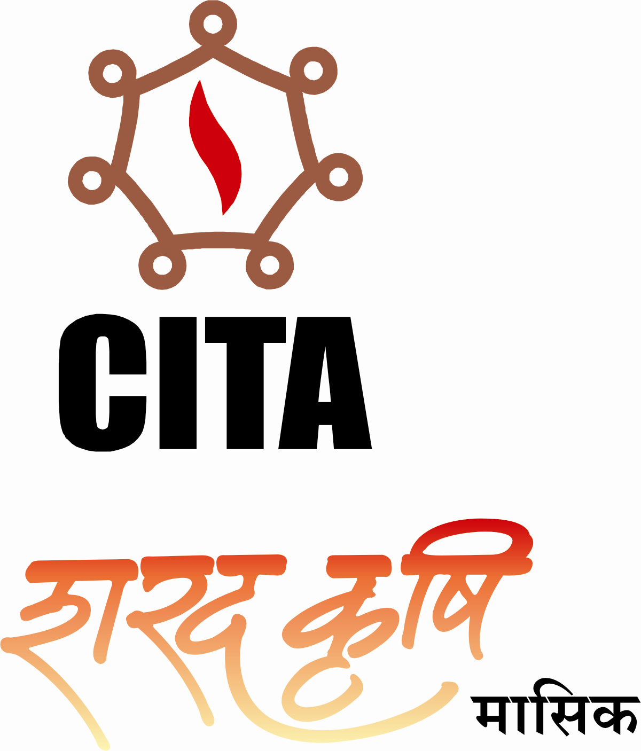

Subscription
Annual - Rs.220/- Biennial - Rs.425/- Five Years - Rs.1000/-
Remittance by DD/MO in the name of 'Sharad Krishi', payable at Pune
Telefax - 91 20 25533122, e-Mail : sharadkrishi@gmail.com

Also available in all Post Offices in following districts :
(Pune, Satara, Sangli, Kolhapur, Nasik, Aurangabad, Jalna, Osmanabad, Amravati, Buldhana)

Sharad Krishi - Awards

Choudhari Charan Singh Award for Journalism in Agricultural Research & Development -
Indian Council of Agricultural Research under the Union Ministry of Agriculture and Cooperation conferred this award for year 2007 to Dr. Mahendra Madhup, Senior Journalist and Editor, Sharad Krishi (Hindi). For the first time, a journalist from Rajasthan received this Rs.1.00 lakh award and citation at the hands of Hon'ble Shri. Sharad Pawar, Union Minister for Agriculture.
Atmaram Award for development of technical and scientific literature in Hindi
Kendriya Hindi Sansthan under the Union Human Resource Development Ministry conferred the Rs.1.00 lakh 'Atmaram' Award to Dr. Mahendra Madhup, Senior Journalist and Editor, Sharad Krishi (Hindi). Dr.Madhup received this award and citation at the hands of Her Excellency the President of India Hon'ble Smt. Pratibhatai Devisingh Patil at the Rashtrapati Bhavan.

